Real Time Streaming with AWS and Snowflake

Objective
The objective of this project is to create a real-time data streaming pipeline that captures, processes, and stores data using AWS services and Snowflake. The pipeline will simulate data ingestion via Postman, process it through AWS services (API Gateway, Lambda, Kinesis, Firehose, and S3), and utilize Snowflake features such as Snowpipe for seamless data integration into the Snowflake environment.

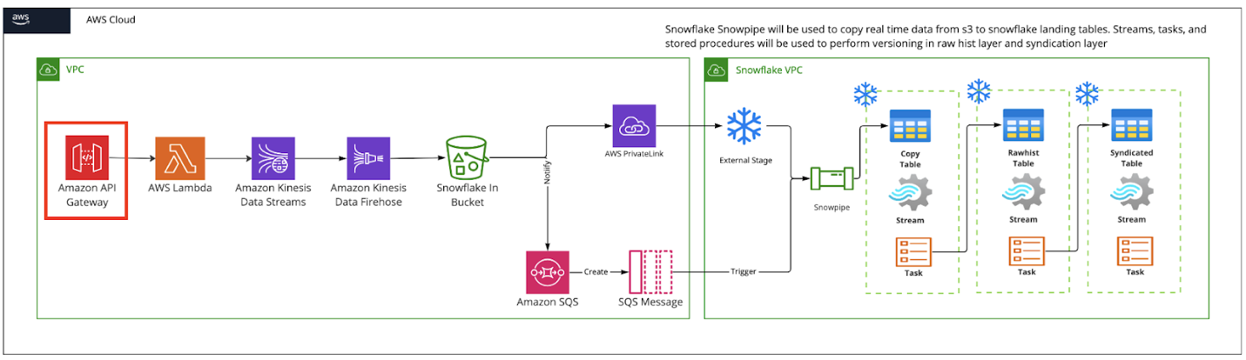
Data Flow Process:
- Json data is uploaded via Postman to the API Gateway.
- API Gateway triggers a lambda function to examine data, if valid, it sends it to Kinesis. If invalid, it is sent to a separate S3 folder for error handling.
- After data is sent to Kinesis, it goes through the firehose and into the S3 bucket.
- When valid data arrives in S3 bucket it is sent through snowpipe automatically through SQS notification (Created during snowpipe setup)
- Raw data (json data) can then be copied into first table manually or tasks can be setup to copy data to first table and sent to second table for transformation.

